1. A particle initially traveling at 30 m/s slows to a stop in just 3 seconds at a constant acceleration. How far does the particle travel?

(A) 10 m

(B) 30 m

(C) 45 m

(D) 80 m

(E) 100 m

2. A projectile is launched at an angle of 30° to the horizontal from a 15 m platform. Its initial velocity is 20 m/s. How far does it travel?

(A) 17 m

(B) 35 m

(C) 52 m

(D) 69 m

(E) 90 m

3. A small moon is held in orbit around a planet by gravity. The radius of the orbit is r. If the speed of the moon were reduced by a factor of 2, the new orbital radius of the moon would be:

(A) 4r

(B) 2r

(C) *r*

(D) 0.5*r*

(E) 3*r*

4. A man dangles a 10 kg mass from the end of a rope. If the man releases the rope, what is the tension in the rope the moment after it is released?

(A) 0 N

(B) 50 N

(C) 100 N

(D) 200 N

(E) 300 N

5. A force of 148 N is applied to the handle of a lawnmower. The handle makes an angle of 53º with respect to the horizontal. The lawnmower has a mass of 20 kg. What is the horizontal acceleration of the mower if the friction is 21.3 N?

(A) 5 m/s2

(B) 4 m/s2

(C) 1 m/s2

(D) 2 m/s2

(E) 3.39 m/s2

6. Determine the minimum angle at which a curve should be banked so that a car traveling at 28.4 m/s can safely negotiate the curve if the radius of the curve is 189 m.

(A) 12.5º

(B) 15º

(C) 20º

(D) 21.6º

(E) 23.5º

7. Two spherical balls are placed so their centers are 3.46 m apart. The force between them is 2.99×10-8 N. If the mass of the smaller ball is 68.1 kg, what is the mass of the other ball?

(A) 11.5 kg

(B) 40.5 kg

(C) 60.5 kg

(D) 73.3 kg

(E) 78.8 kg

8. A ball on a string swings is a horizontal circle of radius 1.55 m. If its centripetal acceleration is 15.8 m/s, what is the frequency of the ball?

(A) 1.404 Hz

(B) 0.001 Hz

(C) 4.802 Hz

(D) 1.209 Hz

(E) 0.508 Hz

9. When a 13.2 kg mass is placed on top of a vertical spring, the spring compresses 5.93 cm. Find the force constant of the spring.

(A) 4900 N/m

(B) 1001 N/m

(C) 1200 N/m

(D) 1400 N/m

(E) 2181 N/m

10. A car moving at 35 m/s on dry pavement, skids to a stop in 7 seconds. What is the coefficient of friction between the car’s tires and the pavement?

(A) 0.2

(B) 0.5

(C) 1

(D) 2

(E) 3

11. A 6.1 kg block rests over a hole in a table. A 37.3 g bullet is shot straight up into the block. The bullet and block rise 0.637 m above the table. What speed did the bullet have just before hitting the block?

(A) 167 m/s

(B) 500 m/s

(C) 220 m/s

(D) 149 m/s

(E) 581 m/s

12. A mass of 2 kg is raised through a vertical distance of 20 m. If the gravitational acceleration is 9.8 m/s2, then the potential energy gained by the mass is

(A) 210 J

(B) 420 J

(C) 882 J

(D) 810 J

(E) 392 J

13. If the same force were applied to each of the following, the change in momentum would be the greatest for:

(A) A 5 kg ball moving at 9 m/s

(B) A 7 kg ball moving at 7 m/s

(C) A 10 kg ball moving at 5 m/s

(D) The change in momentum would be the same for all three.

(E) A 10 kg ball moving at 4 m/s

14. What minimum force F is required to lift the mass?



(A) 15 N

(B) 20 N

(C) 30 N

(D) 60 N

(E) 98 N

15. 11*C* produces a positron to from:

(A) 10*B*

(B) 11*B*

(C) 12*C*

(D) 11*N*

(E) 12*N*

16. A diver swims in a pool that is 30 m deep. The diver swims 20 m above the bottom. If the diver descends to 10 m above the bottom, what is the gauge pressure?

(A) 1×104 Pa

(B) 2×105 Pa

(C) 4×105 Pa

(D) 6.6×105 Pa

(E) 1×105 Pa

17. An open container of fluid begins draining a spigot at time t = 0. Assume ideal fluid flow. If the container is filled with water, and h is 20 m, the pressure at b is:

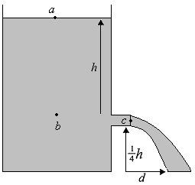

(A) 1 atm

(B) 2 atm

(C) 3 atm

(D) 4 atm

(E) 5 atm

18. As a 5 kg object travels down a ramp, gravity does 60 J of work and friction does -20 J. If the object started from rest, what is its final speed?

(A) 5 m/s

(B) 6 m/s

(C) 7 m/s

(D) 8 m/s

(E) 4 m/s

19. A 50 kg crate slides down a ramp as shown below. Assuming that the ramp is frictionless, find the acceleration of the crate.

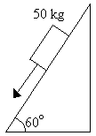

(A) 5 m/s2

(B) 8.7 m/s2

(C) 10 m/s2

(D) 11.3 m/s2

(E) 24 m/s2

20. A 1 m glass tube is stood on end and partially filled with water. The air in the tube resonates when either a 440 Hz or a 1320 Hz tuning fork is vibrated at its opening. It does not resonate with a 147 Hz tuning fork. If the speed of sound in air is 340 m/s, approximately how deep is the water in the tube?

(A) 19 cm

(B) 42 cm

(C) 50 cm

(D) 81 cm

(E) 90 cm

21. A 2 kg block is sliding along a horizontal surface, pulled by a rope that is parallel to the surface. If the tension in the rope is 12 N, and the coefficient of kinetic friction is 0.4, find the acceleration of the block.

(A) 2 m/s2

(B) 4 m/s2

(C) 6 m/s2

(D) 8 m/s2

(E) 1 m/s2

22. What is the potential difference across the capacitor and the charge on the capacitor after the switch is closed for a long time?

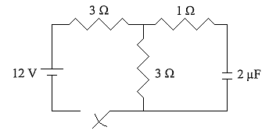

(A) 4 V, 4×10-6 C

(B) 4 V, 1.2×10-5 C

(C) 6 V, 6×10-6 C

(D) 6 V, 1.2×10-5 C

(E) 4 V, 5×10-6 C

23. An object has a charge of -1 coulomb. How many excess electrons does it have?

(A) 6.25×1018

(B) 1.60×1019

(C) 3.20×1019

(D) 6.25×1019

(E) 1.60×1018

24. A 15000 N car on a 30° incline is tied to an immovable object by a rope as shown. If the rope is just strong enough to hold the car in position, what is the minimum breaking force of the rope?

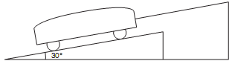

(A) 2500 N

(B) 5000 N

(C) 7500 N

(D) 10000 N

(E) 12500 N

25. The position of a cart moving along the *x*-axis is represented by *x* = 2*t*3+3*t*2–6t, where *x* is in meters and *t* is in seconds. Its acceleration at time *t* = 2 seconds is

(A) 3 m/s2

(B) 12 m/s2

(C) 24 m/s2

(D) 30 m/s2

(E) 36 m/s2

26. The voltmeter reading is closest to

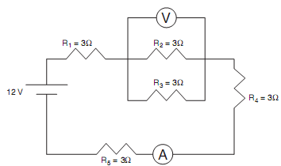

(A) 0.5 V

(B) 1 V

(C) 1.5 V

(D) 2 V

(E) 2.5 V

27. A circular loop of wire is placed in and perpendicular to a magnetic field directed into the page as shown. If the magnetic field’s magnitude is increasing, the resulting current in the wire is

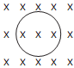

(A) Zero.

(B) Clockwise.

(C) Counterclockwise.

(D) Out of the paper.

(E) Into the paper.

28. The equivalent resistance between points *A* and *B* is

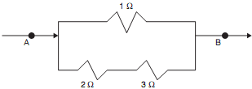

(A) $\frac{2}{3}$ Ω

(B) $\frac{5}{6}$ Ω

(C) Ω

(D) Ω

(E) Ω

29. Doing 1000 J of work on a 50 kg mass will cause it to be lifted to a shelf of height

(A) 1 m

(B) 2 m

(C) 3 m

(D) 4 m

(E) 5 m

30. A 100 Ω, 120 Ω, and 150 Ω resistor are connected to a 9 V battery in the circuit shown in the below. Which of the three resistors dissipates the most power?

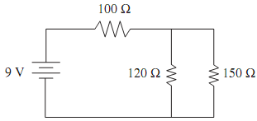

(A) The 100 Ω resistor

(B) The 120 Ω resistor

(C) The 150 Ω resistor

(D) Both the 120 Ω and 150 Ω

(E) All dissipate the same power